

BARBADOS ELECTRONIC SINGLE WINDOW FOR TRADE

ePAYMENT USER GUIDE

Contents
Introduction 3
ACCESSING ONLINE PAYMENT 4
ENTER DETAILS FOR ONLINE PAYMENT 5
ADD PAYMENT DETAILS 6
EZpay PROCESSING 8

Introduction
The Barbados Electronic Single Window for Trade (BeSWIFT) enables access to digitalized services in support of regulating cross-border trade in Barbados “Reaching Beyond Borders”. Traders can conveniently utilize the dedicated portal through any reliable web browser, and complete transactional services for the Participating Government Agencies (PGAs) authorizing the import, export and transit of regulated goods. The services provided via the platform are in accordance with the legislative and procedural framework under which the PGAs operate. Traders who request BeSWIFT services for the processing of Licences, Permits, Certificates, and other (LPCO) prerequisite cargo clearance documents, will benefit from predictable and streamlined processing flows, which incorporate real-time transactional updates and notifications for the suite of services onboarded to the platform.

BeSWIFT serves as a SINGLE access point for:

- Online LPCO Application Submission
- Upload LPCO Supporting Documentations
- Interface with Other Related Government Systems
- Real-Time Notifications on LPCO Transactions
- Track and Trace of LPCO Transactions
- Making Electronic Payments for LPCO Transactions
- Online Verification of Validity Checks of LPCO Transactions

The epayment/ online payment process engaged in BeSWIFT is integrated with EZpay. This document outlines the steps to execute epayment/ online payments using BeSWIFT.

ACCESSING ONLINE PAYMENT
- While logged into the BeSWIFT platform Navigate to menu on the left of the screen

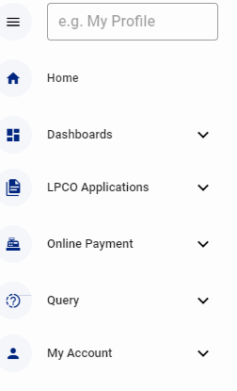
Figure1. Menu

- Expand Online Payment. Refer to Figure 2

- Expand online payment and select online payment order

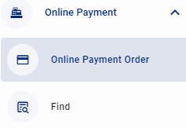
Figure 2. Online payment menu

ENTER DETAILS FOR ONLINE PAYMENT
- Select the Trader TIN from the drop own List as in Figure 3a. Below.

- The Traders name will default on tab
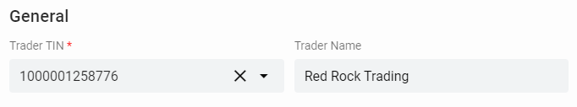
Figure 3a. Traders Info

- Expand LPCO Application and select “Add LPCO Application” refer to Figure 3b.
Figure 3b. Expanded LPCO Segment

- A pop up will appear as seen at Figure 3c. This pop out is completed as indicated at Steps 5 to 9

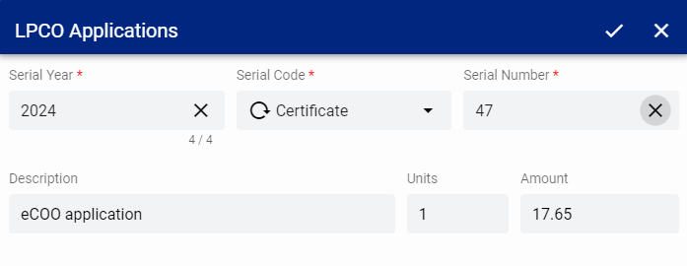
Figure 3c. LPCO Application Detail pop out

- Enter the serial year

- Select the serial Code from the drop-down list whether CER, PER

- Enter the Serial Number which can also be referred to as the LPCO number and Tab

- The description, units and amount field will auto populate

- Select the check at the top of the check box to save
- Information is returned to the payment form

ADD PAYMENT DETAILS
- Expand the Payment Methods Segment select “Add Payment Method”
Figure 4a. Expand Payment Method

- On selection of add payment method a pop up appears select EZpay at type and save by selecting the check at the top right as noted at Figure 4b,

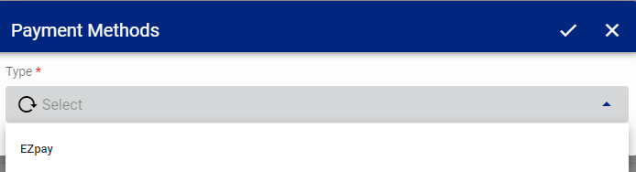
Figure 4b. Payment Method

- The payment type and amount payable is returned to the form as seen below
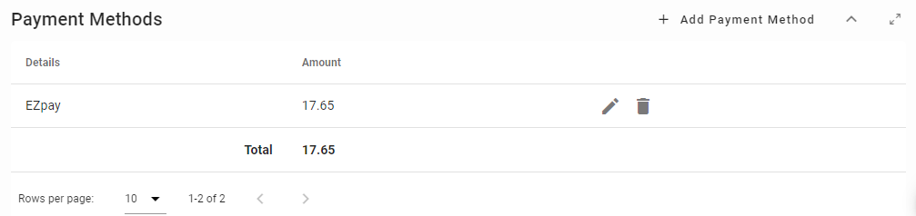
Figure 4c. Payment Method at the Window

- At the form action tab select verify document refer to Figure 4d.
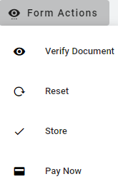
Figure 4e. Verify Document

- Select proceed
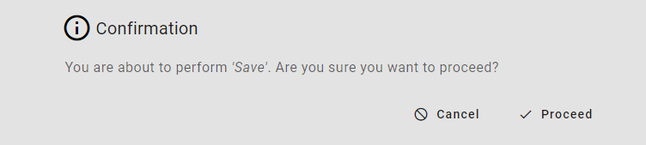
Figure 4f. Confirmation
- Review message

- If successful access Form Action located at the top right of the page select Pay Now


Figure 4g. Pay Now

- This will direct you to the EZpay Platform

EZpay PROCESSING
- Select Checkout as Guest. Reference Figure 5a.
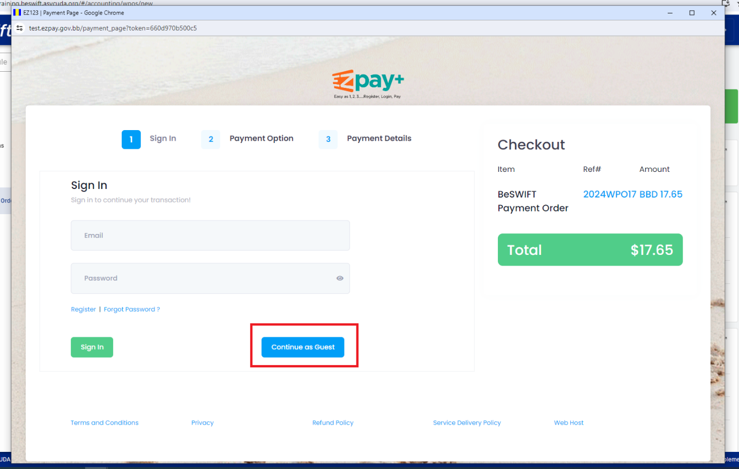
Figure 5a. Continue as guest

- At the payment option tab select next as seen in Figure 5b.
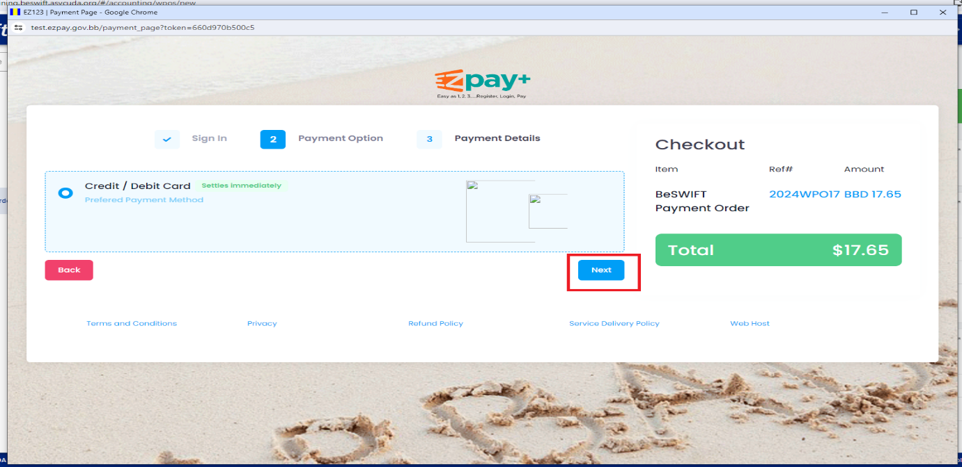
Figure 5b “Next”

- At the next prompt enter the following. Refer to Figure 5c.
- Card holder name
- Card number
- Expiry month Exp Year
- CVV
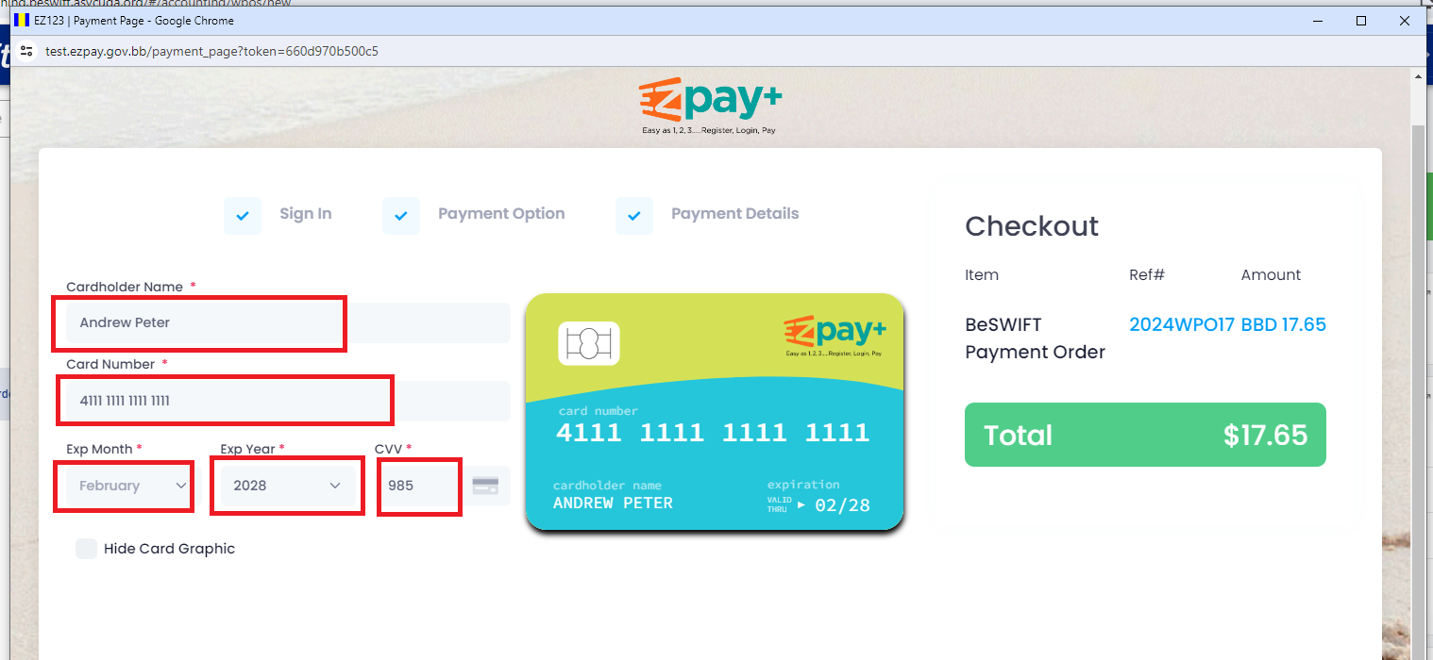
Figure 5c. Card information

- Enter the following billing information as noted at Figure 5d.
- Address
- City
- Country
- Zip Code
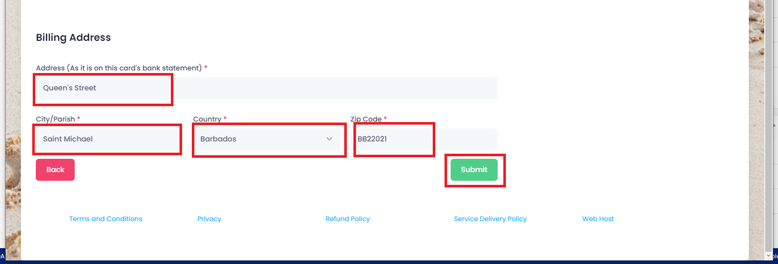

- Select Submit please refer to Figure 5d.

- On submission a pop up appears as at Figure 5e. select Yes, Continue to complete payment process or cancel to exit from payment process

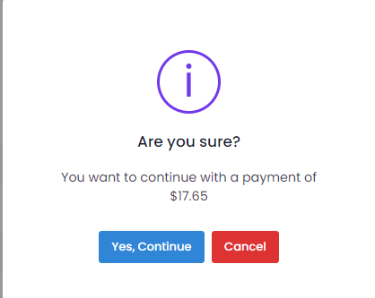
Figure 5e. Complete payment Process

- The pop up shown at Figure 5f. shows the payment was success full select ok.
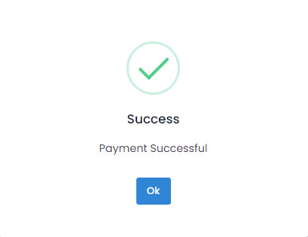
Figure 5f. Payment Success

